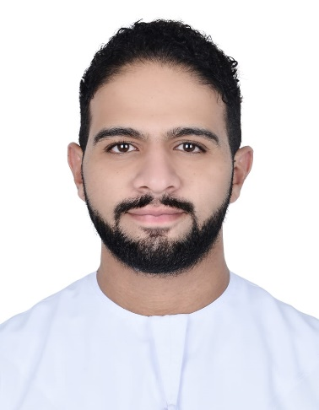
Mahmoud Salah Elbaz

Address: Al Nahyan, Al Meel St. - Villa No.65 – Flat no. 104 – Abu Dhabi – U.A.E

Phone: +971528885245

E-Mail: mahmoud.s.e@hotmail.com

PERSONAL SUMMARY
A responsible person who seeks to add up experiences in career and to lift up the company profile to its expectations.
Worked on various administrative and manageable roles with expert skills, team oriented and a motivated quick learner.
Proficient in handling customers with better language skills and solving the issues they are facing.
Looking to pursue a rewarding career.

EDUCATION
- Studying Bachelor Of Health Management in Al Khawarizmi International College (Abu Dhabi Campus).
- Graduated from Al-Nahda national schools with an American diploma certificate year 2011 / 2012.
- IGCSE certificate year 2010. (British Syllabus)

CAREER HISTORY
- FULL TIME: -
- Working currently with SEHA (AHS) in Madinat Khalifa Healthcare Center as a Patient Access Representative since July 2020 and been in the frontliners team throughout the Covid pandemic.

    - Worked in Burjeel hospital in Abu Dhabi as a Guest Service Executive for 2 years from March 2016 – February 2018.

- PART TIME: -

- 2022: -
- Worked in Maritime Heritage Festival in Al Bahar, Corniche Abu Dhabi from 18-27 March as a Zone Manager.

- 2021:-
- Worked in Al Hosn Festival in Al Hosn, Abu Dhabi from November 27 to December 4 as a Zone Manager.

- 2020:-
- Worked with the Department Of Health ( DOH ) for a month from April to May in preparing the watches for quarantine.
- 2019: -
- Worked in Al Diriyah Season in Riyadh, KSA as an assistant zone manager in al diriyah festival.
- Worked in the Asian Federation Cup as a Box office Manager.
- Worked in the Pope Francis visit event in Zayed Sports City in Abu Dhabi as a location manager.
- Worked in the Abu Dhabi Science Festival in Al Dhafra as a Team Leader.
- Worked in the Special Olympics World Games in Zayed Sports City as a Venue Media Assistant Manager.
- Worked in the World Rally Cross Championship in Yas Marina Circuit as a Ticketing Manager on the gates.
- Worked in the Abu Dhabi International Book Fair in ADNEC as a location manager of the registration and information desks staff.
- Worked in the Cultural Foundation’s Theatre in Abu Dhabi as an Artist Liaison Officer since its reopening in September for its first season in several concerts, shows and performances.

- 2018: -
- Worked in the Abu Dhabi International Book fair in ADNEC as a location manager of the Information booth staff.
- Worked in the Dubai World Cup for horsing races in Meydan in the accreditation team.
- Worked in Mohamed Bin Zayed Majlis for Future Generations in ADNEC in the accreditation team.
- Worked in Ruwais Festival in Ruwais as a location manager of the ushers.

- Worked in Qasr Al Hosn Festival in Abu Dhabi in the accreditation team.
- Worked in the Formula 1 – Fan Zone in Yas Island – Abu Dhabi as a location Manager of the Ushers.

- 2017
    - Worked in the Abu Dhabi International book fair in ADNEC as a supervisor of the information booths staff.
    - Worked in the Abu Dhabi Science Festival in Khalifa Park as a supervisor of one of the workshop zones.
    - Worked in the Formula 1 Pit-Zone area in Yas Island, Abu Dhabi as a supervisor of the staff in the Game zones.

- 2016
    - Worked in the Formula 1 After –Race Concerts in Yas Island, Abu Dhabi as a box office supervisor.
    - Worked in the Abu Dhabi Science Festival in Mushrif Park as a Supervisor of the information booths staff.
    - Worked in the Mubadala World Tennis Championship in Zayed sport city, Abu Dhabi as a supervisor of the scanners and the info booths on the gates.
    - Worked in Qasr Al Hosn Festival in Abu Dhabi as a cash supervisor for the whole gates in the festival.
    - Worked in several concerts and events as a supervisor of staff in different positions.

KEY SKILLS

Courses :-

International Test of English as a foreign Language (TOEFL).

International Computer Driving License (ICDL).

MISCELLANEOUS

LANGUAGES KNOWN |  | PERSONAL DATA
English | : Very Good | Date of Birth | : - 2/08/1995
Arabic | : Mother Tongue | Marital Status | : - Single
 |  | Nationality | : - Egyptian  (born & raised in AD)
 |  | Religion | : - Muslim
- ➢ Notice: - I have a transferable residency.
- ➢ I have a UAE license.

