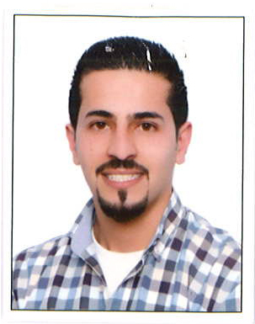
Mob no.09710555751948
Home no097167430025
E-mail: hussam_2006a@hotmail.com
Sharjah, UAE

Husam Najim – Senior Accountant

Personal Information

Birth: Jerusalem, 1990
Nationality: Jordanian
Marital Status: Married
Languages: Arabic and English

Objective

Looking for a full time position as an accountant in a growth oriented company where I can demonstrate my skills and contribute to.

Education

Sep, 2008 to Jan, 2012
Birzeit University, Palestine
Bachelor Degree in Accounting

July 2008
Ramallah Secondary Boy’s School – Literary Stream

Certifications

Value Added Tax (VAT) – Talal Abu Ghazaleh Professional Training Group (Feb 2018)

Training Courses

- Methods of Detecting Forgery in Banknotes & Documents
- Risk Management
- Teamwork training
- Training course of Qualification Banking.
- Financial excel.

Professional Experience

April 2015 up to present
General Accountant- Cubita Trading LLC.
Dubai, UAE

Responsibilities
- Prepare monthly financial statements, reports and records by collecting, analyzing and summarizing account information.
- Responsible for general ledger.
- Fixed asset processing and reporting.
- Maintain bank accounts by requesting disbursements.
- Handle Vat Reporting (Payables And Receivables). Ensure Collections And Payment are done in line with UAE Regulations
- Prepare and manage all documents in line with VAT regulations and other related activity
- Auditing and verifying documents.
- Following internal controls.
- Providing accounting and clerical support to the Accounting/ Administration Division .
April 2014 till March 2015
Accountant – Mena Investment
Ramallah-Palestine

Responsibilities

- Reviews & verifies all daily transactions & makes sure supporting documents are attached (e.g. Invoices, Receipts) before data entry.
- Inputs all daily transactions (expenses, bank deposits, transfers…) on the relevant software including purchases & their respective shipping charges.
- Organizes & files all accounting documents & related attachments.
- Computes payroll on monthly basis according to the country legal requirements & attach all supporting documents & approvals.
- Prepares & computes all legal requirements in regards to taxes (income, VAT, social security) and make sure all reports are submitted correctly and on time.

February 2012 till March 2014
Customer Service Head, Teller, Loans, ATM Machine Reloader-Bank of Palestine
Ramallah Palestine

Responsibilities

- Review and audit
- Working as a teller
- Customers Services
- Clearing

Sep, 2011 to Nov 2012.
Trainee Accountant at Jef Trading Co.
Ramallah Palestine

Responsibilities

- Training for accounting principles and software.
- Preparing financial statements and reports based on field work.
- Preparing the company’s income tax returns.
- Participating the company’s external auditors.
- Involved in producing and analyzing year – end financial accounts.
- Assisting treasury team in doing bank reconciliations.

Skills

Computer skills:

  - Excellent: MS OFFICE (Word, Excel, and PowerPoint, internet)
  - Good knowledge of using internet.
  - Dealing with computer in general.
  - Arabic and English Printing skills.

Other skills

- Ability to work under pressure and meet deadlines
- Ability to work in team
- Good communication skills
- Strong will of learning and acquiring new experiences.

References

Will be gladly furnished upon request.

